SRM Institute of Science and Technology
Tiruchirappalli
COMPUTER NETWORKS LABORATORY
LAB REPORT
Lab 1 and Lab 3
Field | Details
Name | Pavithra Saravanan
Reg. No. | RA2411030050059
Class / Section | BTECH CSE CYBERSECURITY- A
Date of Experiment | 23/10/26
Software Used | Cisco Packet Tracer

Contents
Lab | Title
Lab 1 | Introduction to Packet Tracer, Peer-to-Peer Communication, Study of Cables and their Color Codes
Lab 3 | Router Configuration (Passwords and Interfaces)

Lab 1: Introduction to Packet Tracer, Peer-to-Peer Communication, Study of Cables and their Color Codes

1. Aim
To get familiar with the Cisco Packet Tracer simulator, to build a simple peer-to-peer network of two PCs connected through a switch, to verify connectivity using the ping command, and to study Ethernet cables (straight-through and crossover) along with their wire color codes.

2. Objectives
- To understand the Packet Tracer interface: workspace, device selection box, connections and the Realtime / Simulation modes.
- To create a small LAN using two end devices (PC-PT) and one switch (2960-24TT).
- To assign static IPv4 addresses and subnet masks to the PCs.
- To test peer-to-peer communication using the ICMP ping utility.
- To study straight-through and crossover cables and their T568A / T568B color codes.

3. Apparatus / Requirements
Item | Description
Software | Cisco Packet Tracer (simulation environment)
End devices | 2 × PC-PT (PC2 and PC3)
Network device | 1 × Cisco Catalyst 2960-24TT switch (Switch1)
Cables | Copper straight-through Ethernet cables (PC to switch)
Addressing | Network 192.168.1.0 with subnet mask 255.255.255.0

4. Theory
4.1 Cisco Packet Tracer
Cisco Packet Tracer is a network simulation tool that lets users design, configure and troubleshoot networks without physical hardware. Its main areas are the logical workspace (where the topology is drawn), the device-type and device-selection boxes (routers, switches, end devices, connections) and the Realtime / Simulation mode switch. In Simulation mode, every packet (PDU) can be followed step-by-step through the network, and the Event List shows each hop and the protocol involved.
4.2 Peer-to-Peer Communication
In a peer-to-peer (P2P) setup, each computer acts as both a client and a server and can communicate directly with another computer on the same network, without a dedicated central server. Here, two PCs communicate with each other through a switch, which forwards frames based on MAC addresses. For the devices to talk to each other, they must be in the same IP subnet.
4.3 Ethernet Cables
Twisted-pair Ethernet (UTP) cables contain four twisted pairs (eight wires) terminated with RJ-45 connectors. The wire arrangement at each end determines the cable type:
Straight-through cable: both ends use the same standard (T568B on both ends). It connects unlike devices, e.g. PC to switch, PC to hub, router to switch.
Crossover cable: one end is T568A and the other is T568B. It connects like devices, e.g. PC to PC, switch to switch, router to router, PC to router.
Note: Modern devices with Auto-MDIX can detect and adjust to either cable type automatically.

5. Procedure
5.1 Creating the Network

Launch Cisco Packet Tracer and familiarise yourself with the workspace, device selection box and toolbar.
From End Devices, drag two PC-PT devices onto the workspace (PC2 and PC3).
From Network Devices > Switches, drag one switch (2960-24TT, named Switch1) onto the workspace.
Using the Connections tool, choose Copper Straight-Through cable and connect each PC (FastEthernet0) to a FastEthernet port of the switch.
Wait until the link indicators on both cables turn green, which shows that the links are up.
5.2 Configuring IP Addresses

Click on the first PC, open the Desktop tab and select IP Configuration.
Select Static and enter IP address 192.168.1.1 and subnet mask 255.255.255.0.
Click on the second PC, open Desktop > IP Configuration and enter IP address 192.168.1.2 and subnet mask 255.255.255.0.
5.3 Testing Peer-to-Peer Communication

On the first PC, open Desktop > Command Prompt.
Run the command: ping 192.168.1.2
Observe the replies to confirm that the two computers can communicate.
5.4 Studying Cables and Color Codes

Examine the different cable types available in Packet Tracer (straight-through, crossover, console, etc.).
Note the color code of each wire for the straight-through and crossover cables (see Section 7).

6. Observations and Results
6.1 Network Topology
The topology consists of two PCs (PC2 and PC3) connected to a Cisco 2960-24TT switch (Switch1) using straight-through cables. Both link lights are green, indicating that the connections are active (Figures 1.1 and 1.2).
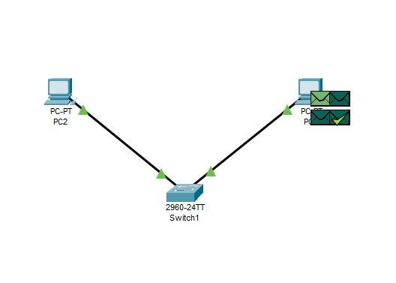
Figure 1.1: Network topology with green link indicators (PC2, Switch1, PC3)

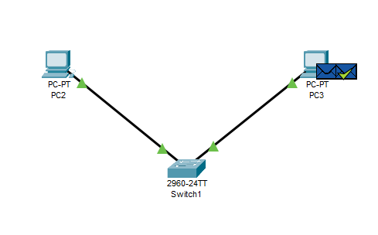
Figure 1.2: Topology after the PDU transfer - successful delivery indicated by the tick on the envelope

6.2 IP Address Configuration
Device | IP Address | Subnet Mask | Connected To
PC (first) | 192.168.1.1 | 255.255.255.0 | Switch1 (Fa port)
PC (second) | 192.168.1.2 | 255.255.255.0 | Switch1 (Fa port)

6.3 Ping Test Result
The ping command was executed from PC3 to 192.168.1.2. All four ICMP echo requests were answered:
Parameter | Result
Command | ping 192.168.1.2
Packet size | 32 bytes
Packets sent / received / lost | 4 / 4 / 0 (0% loss)
Reply times | <1 ms, <1 ms, 2 ms, 1 ms
TTL | 128
Round-trip time (min / max / avg) | 0 ms / 2 ms / 0 ms

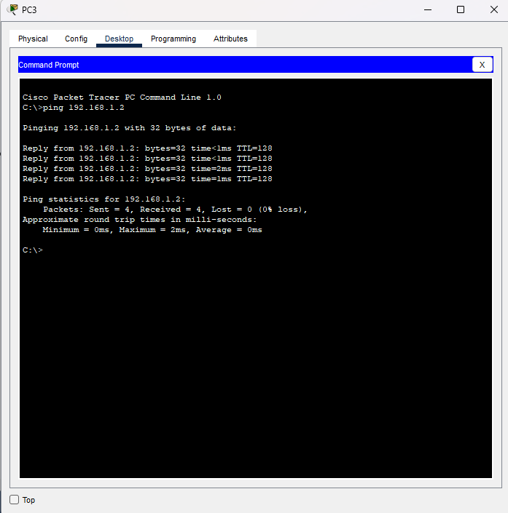
Figure 1.3: PC3 Command Prompt - successful ping to 192.168.1.2 (0% packet loss)

6.4 Simulation Mode Observation
In Simulation mode, the ICMP packet was seen travelling from the source PC to Switch1 and then to the destination PC. The Event List showed the ICMP PDU with status Successful, and the PDU animation (envelope icons) confirmed the echo request and reply path through the switch.
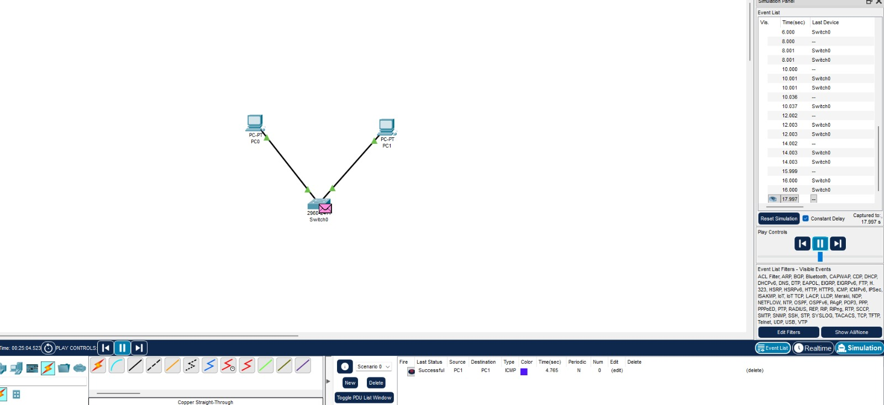
Figure 1.4: Simulation mode - Event List and PDU List showing the ICMP PDU with status Successful

7. Study of Cables and Color Codes
7.1 Wiring Standards
Pin No. | T568A | T568B
1 | White / Green | White / Orange
2 | Green | Orange
3 | White / Orange | White / Green
4 | Blue | Blue
5 | White / Blue | White / Blue
6 | Orange | Green
7 | White / Brown | White / Brown
8 | Brown | Brown

7.2 Straight-Through vs Crossover Cable
Feature | Straight-through cable | Crossover cable
Wiring | T568B at both ends (same order) | T568A at one end, T568B at the other
Pin mapping | 1-1, 2-2, 3-3, 6-6 | 1-3, 2-6, 3-1, 6-2
Used to connect | Different devices: PC to switch, PC to hub, router to switch | Similar devices: PC to PC, switch to switch, router to router
Used in this lab | Yes (PC to Switch) | No (studied for comparison)
Packet Tracer symbol | Solid black line | Solid black line (selected from the crossover icon)

7.3 Pin Functions (10/100 Mbps Ethernet)
Pin No. | Function (PC / Router NIC) | Function (Switch / Hub port)
1 | Transmit (TX+) | Receive (RX+)
2 | Transmit (TX-) | Receive (RX-)
3 | Receive (RX+) | Transmit (TX+)
6 | Receive (RX-) | Transmit (TX-)

A straight-through cable works between a PC and a switch because the PC transmits on pins 1 and 2 while the switch receives on the same pins. Between two PCs (both transmit on pins 1 and 2), the transmit and receive pairs must be swapped, which is exactly what a crossover cable does.

8. Result
A peer-to-peer network of two PCs connected through a switch was successfully created in Cisco Packet Tracer. Static IP addresses 192.168.1.1 and 192.168.1.2 were configured, and the ping test showed 4 packets sent, 4 received and 0% loss, which confirms successful communication. The straight-through and crossover cables and their color codes were also studied.

9. Conclusion
This lab introduced the Packet Tracer environment and showed how to build and verify a basic LAN. Devices in the same subnet, connected with the correct cable type, communicate without any additional configuration. The study of cable standards showed that a straight-through cable (T568B-T568B) is used to connect dissimilar devices, whereas a crossover cable (T568A-T568B) is used to connect similar devices.
Lab 3: Router Configuration (Passwords and Interfaces)
1. Aim
To configure a Cisco router in Packet Tracer by setting console, enable and VTY passwords and assigning IP addresses to two interfaces, then verify connectivity between two networks through the router.

2. Objectives
Move between the router CLI modes: user EXEC, privileged EXEC, global configuration and line configuration.
Secure access with console, enable and VTY passwords.
Assign IP addresses to router interfaces and bring them up with no shutdown.
Test connectivity between PCs on different networks using ping.

3. Theory
A router forwards packets between different IP networks. Each interface sits in a separate network, so a router with two configured interfaces can connect 192.168.1.0/24 and 192.168.2.0/24. Interfaces are administratively down by default and need no shutdown.
CLI mode | Prompt | How to enter
User EXEC | Router> | Default after login
Privileged EXEC | Router# | enable
Global configuration | Router(config)# | configure terminal
Line configuration | Router(config-line)# | line console 0 or line vty 0 4
Interface configuration | Router(config-if)# | interface <name>

Password | Command | Protects
Console | line console 0, password cisco, login | Physical console port
Enable | enable password cisco | Access to privileged EXEC mode
VTY | line vty 0 4, password cisco, login | Telnet or SSH sessions (5 lines, 0 to 4)

The login command makes the line ask for the password. The enable password is stored in plain text unless encrypted with service password-encryption or replaced by enable secret.

4. Topology and IP Addressing
One router connects two PCs, each on its own network, using straight-through cables.
Device | Interface | IP address | Subnet mask | Default gateway
Router1 | GigabitEthernet0/0/0 | 192.168.1.1 | 255.255.255.0 | n/a
Router1 | GigabitEthernet0/0/1 | 192.168.2.1 | 255.255.255.0 | n/a
PC0 | FastEthernet0 | 192.168.1.2 | 255.255.255.0 | 192.168.1.1
PC1 | FastEthernet0 | 192.168.2.2 | 255.255.255.0 | 192.168.2.1

The router in these screenshots numbers its interfaces 0/0/0, 0/0/1 and 0/0/2, so the commands below use that form.

5. Procedure

Launch Cisco Packet Tracer.
Drag one router and two PCs onto the workspace, and connect each PC to the router with a straight-through cable.
Click the router and open the CLI tab.
Set the passwords (below).
Configure both router interfaces and bring them up (below).
Set the PC addresses: 192.168.1.2 on the first PC and 192.168.2.2 on the second, with the router interface as default gateway.
Ping between the PCs through the router.
5.1 Passwords
Router>enable
Router#configure terminal
Router(config)#line console 0
Router(config-line)#password cisco
Router(config-line)#login
Router(config-line)#exit
Router(config)#enable password cisco
Router(config)#line vty 0 4
Router(config-line)#password cisco
Router(config-line)#login
Router(config-line)#exit

5.2 Interfaces
Router(config)#interface gigabitEthernet 0/0/0
Router(config-if)#ip address 192.168.1.1 255.255.255.0
Router(config-if)#no shutdown
Router(config-if)#exit
Router(config)#interface gigabitEthernet 0/0/1
Router(config-if)#ip address 192.168.2.1 255.255.255.0
Router(config-if)#no shutdown
Router(config-if)#end
Router#show ip interface brief

6. Configuration Screenshots

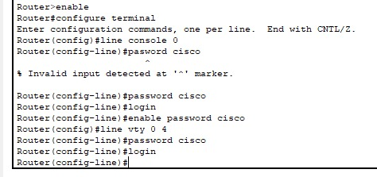
Figure 3.1: Password configuration in the router CLI. The first attempt at password cisco was mistyped and rejected with an invalid-input error; the corrected command was accepted.

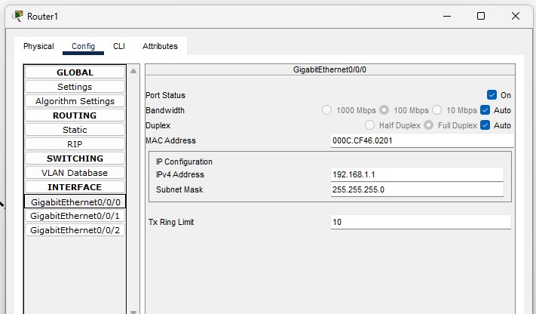

Figure 3.2: GigabitEthernet0/0/0 set to 192.168.1.1 / 255.255.255.0, port status On.
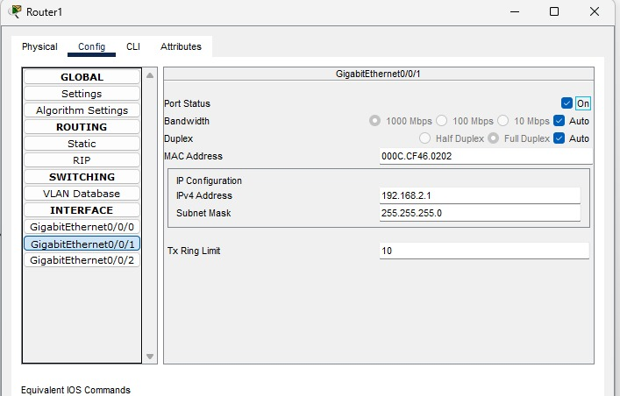
Figure 3.3: GigabitEthernet0/0/1 set to 192.168.2.1 / 255.255.255.0, port status On.

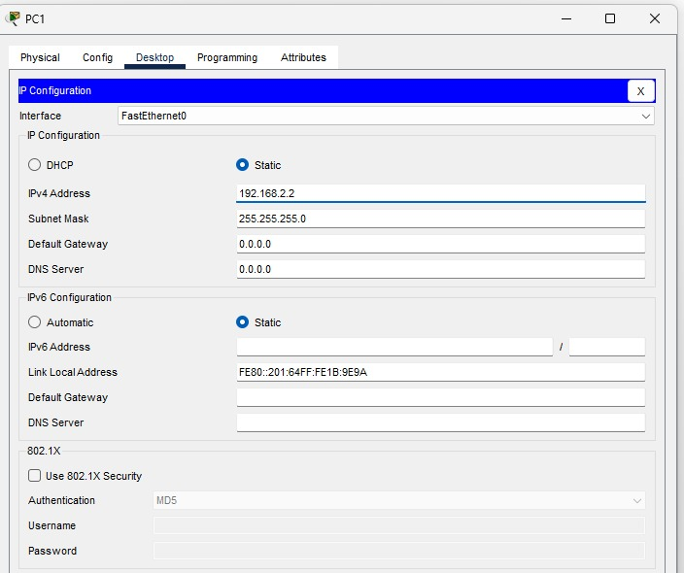
Figure 3.4: PC1 static IP configuration, 192.168.2.2 / 255.255.255.0. The default gateway in this capture is 0.0.0.0; it must be 192.168.2.1 for PC1 to reach the 192.168.1.0 network.

7. Connectivity Test
Both ping tests succeeded with 4 of 4 replies and 0% loss.
Ping target | Sent / received | Lost | Min / max / average
192.168.2.2 (PC1) | 4 / 4 | 0 (0%) | 0 ms / 7 ms / 2 ms
192.168.2.1 (Router1, GigabitEthernet0/0/1) | 4 / 4 | 0 (0%) | 2 ms / 6 ms / 4 ms

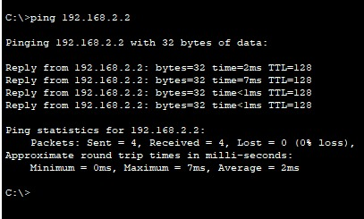
Figure 3.5: Ping to 192.168.2.2.
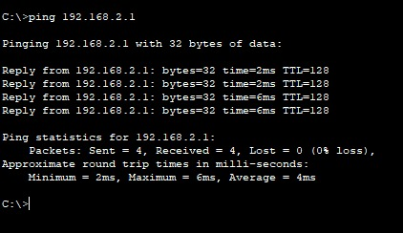
Figure 3.6: Ping to 192.168.2.1.
The replies show that the router interface is up with the configured address and that the second network is reachable.

8. Result and Conclusion
The router was secured with console, enable and VTY passwords, and both interfaces were configured as 192.168.1.1 and 192.168.2.1 with mask 255.255.255.0. Ping tests to 192.168.2.2 and 192.168.2.1 returned 4 of 4 replies with 0% loss, confirming the configuration works.

